Guide
SuiteCommerce Standard

Customization 1
Checkout view:
- On entry point, get customer info
- Get checkbox of terms
- Get checkout component and add a view if terms are X
- On view hide “credit card” button.

Order wizard?
Is ACH button there natively?

60hs

Customization 2
My Account view:
No way to delete that via SCMyAccount. The only way is via CSS.

Add credit card button hide
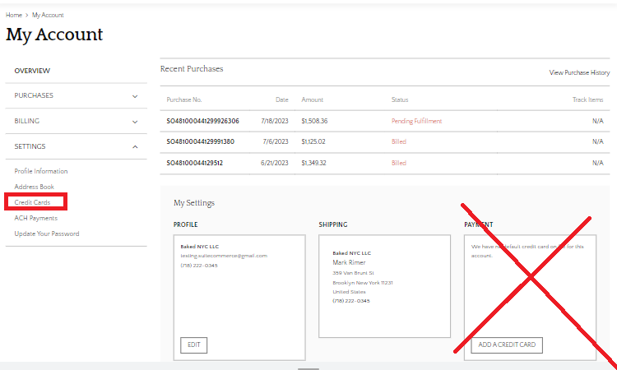
We also need data from customer to decide to hide it or not, I do not know if that’s feasible. Perhaps get on entry point this data and then call a dummy view to hide it.
On SCMyAccount, extensibility layer does not provide operations to hide this button.

Last credit card on my account hide removal button

This as well can be done via CSS, but we need to check if there is a way we could count the amount of credit cards available via html, if there more than 1 html tag with that exact name then we do not hide it, if there is only 1 we hide the remove button.

Solution
Crear un custentity field:
Customization -> List, Records & fields -> Entity fields
Y agregar en customer, contact, y website para que llegue al website.
Inside getUserProfile:
Use addToViewContextDefinition with a function from SCA code to remove credit card button payment option totally, and then hide the credit card list below with removeChildView.
Also remove payment-credit card section on overview view with removeChildView.

layout.removeChildView('Overview.Payment');
layout.removeChildView('CreditCard.List');
layout.addToViewContextDefinition('PaymentWizard.Module.PaymentMethod.Selector',
'activeModules',
'array',
function getActiveModules(context) {
var activeModules = context.activeModules;
var achModules = _.chain(activeModules).map(function mapModules(module) {
module.isActive = true;
module.isSelected = true;
return module;
}).filter(function filterModules(paymentModule) {
return paymentModule.name === 'ACH';
}).value();
return achModules;
});

Dummy credit card
4111111111111111
Visa

Create Invoice and Test Functionality
To see the invoice on myAccount and be able to test the ACH button:

Go to customer record -> sales -> select create new invoice
And fill up:
- Location: Global DTC
- Terms: Net 10

Go below to item tab:
- Add miscellaneous item:
  - Cost: 1
  - Amount: 1
  - Location: Global DTC

- Discount: Restocking Fee
- Exchange rate: 1.00

Shipping tab:
- Set shipping and handling cost

Then go to the site:
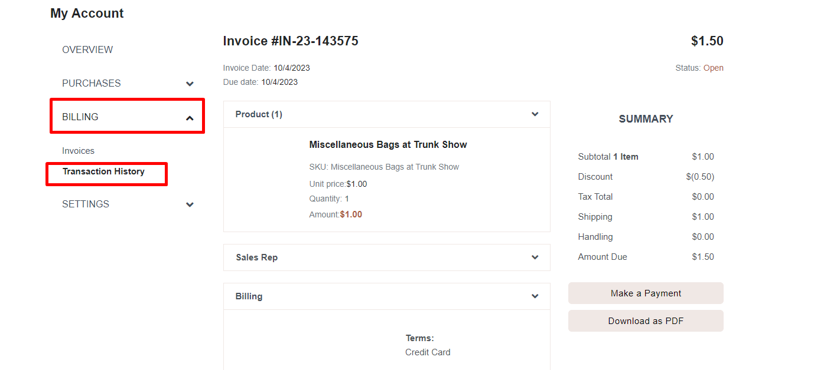
Select Billing -> transaction history -> select an invoice.
Then press on “make a payment”.

// on sandbox .paymentinstrument-creditcard-container

